Environmental product declaration, Levyvilla insulation slabs,

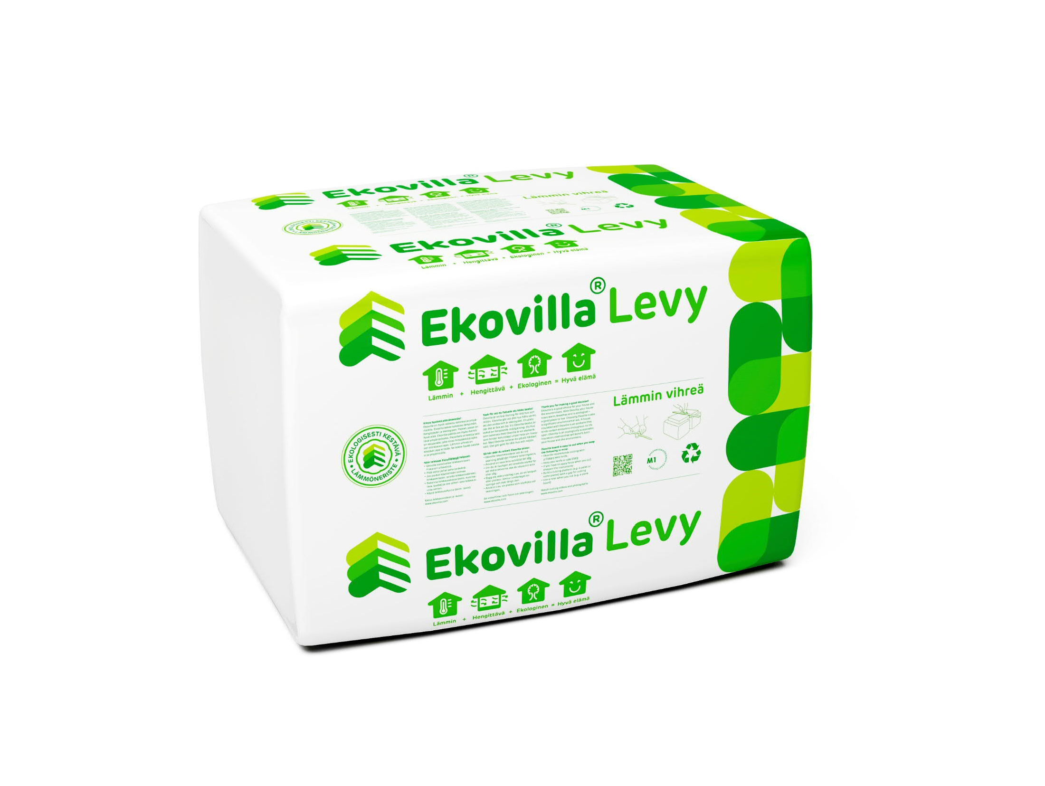
Ekovilla Oy

Product: Levyvilla insulation slabs for wall and roof insulation Manufacturer: Ekovilla Oy, Katajanharjuntie 10, 45720 Kuusankoski Production year: 2018
Functional unit The functional unit is not specified as insulation slabs can be used in various applications. The declared unit is 1 kg of packaged product.

Method The environmental product declaration has been prepared in accordance with the standard EN 15804:2012+A1:2014 and the RTS PCR protocol. Environmental product declarations for construction products may not be comparable with other environmental product declarations if they do not comply with this European EN standard.

EPD scope Covers the production of insulation slabs at the Kuusankoski plant The calculation was performed by: VTT Technical Research Centre of Finland Ltd.
Date 02/01/2020 and update 30/01/2020

Further information: From the manufacturer
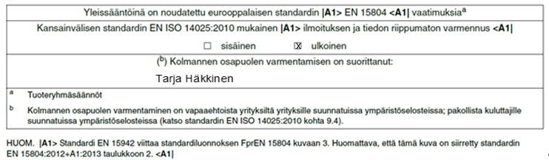

2 (12)

Product description
This environmental product declaration covers the production of Levyvilla insulation slabs at Ekovilla Oy’s Kuusankoski plant. Impact assessment results have been calculated using 12-month production data for 2018/2019.

Ekovilla insulation slabs are made from recycled newspaper, magnesium sulphate and boric acid and staple fibre (polyester). The product can be used as heat insulation and as additional heat insulation in roofs, walls and floors.

Table 1. Technical specifications
Installation density, kg/m3 | 32 - 42
Thermal conductivity, λ, W/mK | 0.039
Service life, years | 50 years (product manufacturer’s estimate)
Technical approval | DOP / CE marking

Scope of the EPD
This EPD covers the product stage, installation service and maintenance, repairs, dismantling, reuse, recovery of waste in material recycling, energy recovery from waste and disposal of waste. This cradle-to-grave EPD covers the whole life cycle of the product, i.e. information modules A1 to C4, as well as the impacts outside the life cycle, i.e. module D (net impacts of reuse, recovery and recycling after the life cycle).

Production and product information are based on ‘actual’ manufacturing data collected by the manufacturer from the production facility. The EcoInvent database, version 3.6, has been the general source of information for additives, wind power, natural gas and container vessels. The ELCD database has also been used for fuel sourcing (EU15, PE International, Germany). VTT’s Lipasto unit emission database (average haulage equipment in 2016) has been used as the environmental profile for road transport, to which emissions from fuel sourcing have always been added according to the life cycle assessment requirements and, as average loads as declared by the manufacturer, load sizes have also been taken into account.

Product stage (A1-3)
The product stage covers all raw materials, packaging materials, transport and the manufacturing process in the production of the insulation slabs. The maintenance of machinery has not been taken into account in the assessment due to its minor significance.

Ekovilla Oy works with the organisation that collects recycled paper and has thus had a say on where the paper is collected. According to the manufacturer, increasing quantities of reclaimed paper are collected from the surrounding areas. Reclaimed paper is assumed to be waste, and no environmental impacts have been associated with its production.

Mixed waste, recoverable incineration residue and compost litter are generated in the production of insulation slabs. Waste processing is described at the end-of-life stage (module C).

After manufacturing, insulation slabs are packaged in plastic packaging. Ekovilla uses recycled plastic, which can also be recovered after use, as well as non-recyclable plastic. It is assumed in this calculation that all packaging plastic is made of virgin raw material and goes to incineration after use.

The carbon content of insulation slab raw materials has been taken into account in the calculation. This assessment is based on a reference (Nors, M., 2009).

A1 Raw materials A2 Transport A3 Production

Recycled paper
Energy, fuel, water

Insulation slab

Transport
Fire retardants
Transport
Transport
Production process

Transport

Transport

Staple fibre (polyester)

Image 1. Simplified insulation slab manufacturing process.
Virgin packaging materials
Recycled packaging materials
Recyclable waste

Waste to energy
Unusable waste

Construction stage (A4-5)
The packaged end product is transported to the construction site. Insulation materials are light, which means that the transport capacity is a significant factor. Insulation slabs are transported in a full trailer truck. The average load factor in the calculation is 12% (a 40-tonne truck can hold 4.224 tonnes of packed insulation slabs and 0.56 tonnes of wooden pallets).

Insulation slabs are installed by hand on site. It has been assumed that no waste is generated during the installation process.

Use stage (B1-7)
According to the manufacturer, it can be assumed that during 50 years of use in normal conditions, the product will not require any maintenance or repairs. This means that the environmental impacts of stages B are 0.

End-of-life stage (C1-4) and impacts outside the life cycle (D).

Insulation slabs can be removed from the structure by hand after a building’s end-of-life stage, and the recovered product can be turned into blown wool. The end-of-life stage includes the assumption that the product used is 100% reusable. Information modules in the end-of-life stage cover the following processes:
- C1 – De-construction demolition. The assessment takes into account that insulation slabs are removed from buildings by hand, which does not cause any environmental load.
- C2 – Transport during the demolition phase. Includes the transport of packaging waste (plastic packaging) to an incineration plant, the transport of mixed waste to final disposal, the transport of waste used in energy generation to an incineration plant, the transport of compost litter to a composting plant and the transport of removed product to a temporary store and from the temporary store to the factory to be used in the production of blown wool.
- C3 – Waste processing:
  - Treatment of waste used for energy generation and packaging waste in an incineration plant
  - Production of recovered insulation slabs into blown wool (the calculation used the same energy consumption as in the production of virgin blown wool).
  - The production also generates compost litter, but this is not a separate product that Ekovilla produces but reusable waste generated as a by-product. As soon as compost litter arrives at the plant where it is used, it is no longer considered waste. This calculation does not include the processing of compost litter when it is reused.
  - The stage also takes into account the content of biogenic carbon transferred in the recycling process to the next product system, calculated as CO2, when the impact of biogenic CO2 on the GWP in a product’s life cycle must be 0 according to EN16485:2014.
- C4 – Disposal of waste. Landfill treatment of mixed waste. The impacts outside the life cycle are covered in information module D. The assumption regarding the end-of-life stage was that insulation slabs can be 100% reused in the production of blown wool, so that used insulation slabs replace the production of new blown wool.

Results

Table 2.a Environmental impacts (life cycle stages A1-5)
Parameters and unit | A1 | A2 | A3 | A1-3, total | A4 | A5 | A1-A5, total
GWP, kg CO2 eqv/kg | 0.63+ (-1.24)  = -0.61* | 0.037 | 0.18 | -0.40 | 0.059 | 0 | -0.34
ADP elements, kg Sb eqv/kg | 6.1E-03 | 1.7E-04 | 1.4E-03 | 7.7E-03 | 2.6E-09 | 0 | 7.7E-03
ADP fossil fuels, MJ/kg | 12.6 | 0.48 | 2.39 | 15.5 | 0.91 | 0 | 16.4
AP, kg SO2 eqv/kg | 2.8E-03 | 7.5E-04 | 2.4E-04 | 3.7E-03 | 2.0E-04 | 0 | 3.9E-03
ODP, kg CFC11 eqv/kg | 5.8E-08 | 4.4E-09 | 1.6E-08 | 7.8E-08 | 1.3E-10 | 0 | 7.8E-08
EP, kg (PO4)⁻³ eqv/kg | 8.4E-04 | 8.8E-05 | 2.1E-04 | 1.1E-03 | 4.3E-05 | 0 | 1.2E-03
POCP, kg C2H4 eqv/kg | 1.7E-04 | 2.1E-05 | 2.6E-05 | 2.2E-04 | 1.4E-05 | 0 | 2.4E-04
ADP elements - Depletion of non-renewable mineral resources, ADP fossil fuels - Depletion of non-renewable energy resources, AP - Emissions that cause soil and water acidification, ODP - Emissions that deplete the stratospheric ozone layer, GWP - Emissions of greenhouse gases, EP - Emissions that cause eutrophication, POCP - Emissions from compounds that form photochemical ozone in the lower atmosphere.
*The GWP of stage A1 for the production of raw materials is 0.63 kg CO2eqv/kg, and the biogenic carbon content of the raw materials, calculated as CO2 is
-1.24 kg CO2/kg. The negative emission is the biogenic carbon content (calculated as carbon dioxide) that is transferred from the previous product system (recovered paper) to this system.

Table 2b. Environmental impacts (life cycle stages B1-D)
Parameters and unit | B1-7, total | C1 | C2 | C3 | C4 | C1-4, total | D
GWP, kg CO2 eqv/kg | 0 | 0 | 2.1E-03 | 0.11 | 7.9E-04 | 0.13 | -0.096
GWP, kg CO2/kg (biogenic carbon calculated as CO2) that goes to the next product system * | 0 | 0 | 0 | 1.24 | 0 | 1.24 | 0
ADP elements, kg Sb eqv/kg | 0 | 0 | 8.9E-10 | 4.5E-06 | 1.8E-07 | 4.7E-06 | -6.3e-04
ADP fossil fuels, MJ/kg (LHV) | 0 | 0 | 0.30 | 0,0092 | 3.6E-04 | 0.31 | -1.5
AP, kg SO2 eqv/kg | 0 | 0 | 6.1E-05 | 1.0E-05 | 1.6E-07 | 8.0E-05 | -9.8e-04
ODP, kg CFC11 eqv/kg | 0 | 0 | 4.6E-11 | 8.8E-11 | 4.9E-12 | 1.4E-10 | -2.2e-08
EP, kg (PO4)⁻³ eqv/kg | 0 | 0 | 1.5E-05 | 4.1E-06 | 1.0E-06 | 2.0E-05 | -1.9e-04
POCP, kg C2H4 eqv/kg | 0 | 0 | 4.8E-06 | 1.6E-07 | 2.1E-07 | 5.2E-06 | -4.6e-05
* the biogenic carbon content going to the next product system is 1.24 calculated as CO2 (the assumption is that the manufacturer uses
100% of the recovered product in the manufacture of the new product). According to EN16485:2014, the impact of biogenic CO2 on the GWP in a product’s life cycle is 0.

Table 3a. Use of resources, primary energy (life cycle stages A1-5)
Parameter and unit | A1 | A2 | A3 | A1-3, total | A4 | A5 | A1-5, total
Use of renewable energy resources as energy, MJ/kg | 0.58 | 2.6E-03 | 2.5 | 3.08 | 1.2E-03 | 0 | 3.08
Use of renewable energy resources as raw materials, MJ/kg | 0 | 0 | 0 | 0 | 0 | 0 | 0
Total use of renewable energy resources, MJ/kg | 0.58 | 2.6E-03 | 2.5 | 3.08 | 1.2E-03 | 0 | 3.08
Use of non-renewable energy resources as energy, MJ/kg | 12.6 | 0.5 | 2.9 | 16.0 | 0.91 | 0 | 16.9
Use of non-renewable energy resources as raw materials, MJ/kg | 7.4 | 0 | 0 | 7.4 | 0 | 0 | 7.4
Total use of non-renewable energy resources, MJ/kg | 20.0 | 0.5 | 2.9 | 23.5 | 0.91 | 0 | 24.4

Table 3b. Use of resources, primary energy (life cycle stages B1-D)
Parameter and unit | B1-7, total | C1 | C2 | C3 | C4 | C1-4, total | D
Use of renewable energy resources as energy, MJ/kg | 0 | 0 | 4.2E-04 | 2.6E-04 | 5.7E-05 | 7.4E-04 | -0.54
Use of renewable energy resources as raw materials, MJ/kg | 0 | 0 | 0 | 0 | 0 | 0 | 0
Total use of renewable energy resources, MJ/kg | 0 | 0 | 4.2E-04 | 2.6E-04 | 5.7E-05 | 7.4E-04 | -0.54
Use of non-renewable energy resources as energy, MJ/kg | 0 | 0 | 0.32 | 8.2E-03 | 4.63E-04 | 0.33 | -2.7
Use of non-renewable energy resources as raw materials, MJ/kg | 0 | 0 | 0 | 0 | 0 | 0 | -0.25
Total use of non-renewable energy resources, MJ/kg | 0 | 0 | 0.32 | 8.2E-03 | 4.6E-04 | 0.33 | -3.0

Table 4a. Use of resources, other (life cycle stages A1-5)
Parameter and unit | A1 | A2 | A3 | A4 | A5 | A1-3, total | A1-A5, total
Use of recycled materials, kg/kg | 0.85 | 0 | 0 | 0 | 0 | 0.85 | 0.85
Use of renewable secondary fuels, MJ/kg | 0 | 0 | 0 | 0 | 0 | 0 | 0
Use of non-renewable secondary fuels, MJ/kg | 0 | 0 | 0 | 0 | 0 | 0 | 0
Use of water, m³ | 1.4E-03 | 1.2E-03 | 3.2E-04 | 6.7E-03 | 0 | 2.9E-03 | 9.6E-03

Table 4b. Use of resources, other (life cycle stages B1-D)
Parameter and unit | B1-7, total | C1 | C2 | C3 | C4 | C1-4, total | D
Use of recycled materials, kg/kg | 0 | 0 | 0 | 0 | 0 | 0 | -0.90
Use of renewable secondary fuels, MJ/kg | 0 | 0 | 0 | 0 | 0 | 0 | 0
Use of non-renewable secondary fuels, MJ/kg | 0 | 0 | 0 | 0 | 0 | 0 | 0
Use of water, m³ | 0 | 0 | 2.3E-03 | 2.6E-05 | 4.8E-07 | 2.4E-03 | -2.0E-03

Table 5a. Waste categories (life cycle stages A1-5)
Parameter and unit | A1 | A2 | A3 | A4 | A5 | A1-3, total | A1-A5, total
Hazardous waste, kg/kg | 2.9E-03 | 3.2E-07 | 3.6E-06 | 0 | 0 | 2.9E-03 | 2.9E-03
Non-hazardous waste, kg/kg | 5.5E-02 | 8.3E-04 | 0.18 | 3.6E-05 | 0 | 0.24 | 0.24
Radioactive waste, kg/kg | 1.9E-05 | 2.7E-06 | 8.8E-05 | 1.6E-06 | 0 | 1.1E-04 | 1.1E-04

Table 5b. Waste categories (life cycle stages B1-D)
Parameter and unit | B1-7, total | C1 | C2 | C3 | C4 | C1-4, total | D
Hazardous waste, kg/kg | 0 | 0 | 0 | 1,0E-07 | 1,6E09 | 1.1E-07 | -7.4e-05
Non-hazardous waste, kg/kg | 0 | 0 | 1.3E-05 | 1.5E-03 | 1.6E-03 | 3.1E-03 | -4.7e-03
Radioactive waste, kg/kg | 0 | 0 | 5.7E-07 | 2.1E-08 | 3.2E09 | 5.9E-07 | -5.5e-07

Table 6a. Other environmental impacts (life cycle stages A1-5)
Parameter and unit | A1 | A2 | A3 | A4 | A5 | A1-3, total | A1-A5, total
Components for reuse, kg/kg | 0 | 0 | 0 | 0 | 0 | 0 | 0
Materials for recycling, kg/kg | 0 | 0 | 0 | 0 | 0 | 0 | 0
Materials for energy recovery, kg/kg | 0 | 0 | 0.053 | 0 | 0 | 0.053 | 0.053
Exported (used) energy, MJ/kg | 0 | 0 | 0 | 0 | 0 | 0 | 0

Table 6b. Other environmental impacts (life cycle stages A1-5)
Parameter and unit | B1-7, total | C1 | C2 | C3 | C4 | C1-4, total | D
Components for reuse, kg/kg | 0 | 0 | 0 | 0 | 0 | 0 | 0
Materials for recycling, kg/kg | 0 | 1.0 | 0 | 0 | 0 | 1.0 | 0
Materials for energy recovery, kg/kg | 0 | 0 | 0 | 0.053 | 0 | 0.053 | 0
Exported electrical energy, MJ/kg | 0 | 0 | 0 | 0.20 | 0 | 0.20 | 0
Exported thermal energy, MJ/kg | 0 | 0 | 0 | 0.40 | 0 | 0.40 | 0

CUSTOMER REPORT VTT-CR-00001-20 ANNEX 1
12 (12)

References
EN 15804:2012 + A1:2013 Sustainability of construction works - Environmental product declarations - Core rules for the product category of construction products

SFS EN 16485:2014 Round and sawn timber. Environmental product declarations. Product category rules for wood and wood based products for use in construction.

EN 15942:2012 Sustainability of construction works - Environmental product declarations - Communication format business to business.

ISO 14025:2010 Environmental labels and declarations. Type III environmental declarations. Principles and procedures.

ISO 14044:2006 Environmental management. Life Cycle Assessment. Requirements and guidelines

ISO 14067:2018 Greenhouse gases Carbon footprint of products Requirements and guidelines for quantification

EcoInvent 3.6 database, 2019. http://www.ecoinvent.org/

Lipasto – a calculation system for traffic exhaust emissions and energy use in Finland. VTT Technical Research Centre of Finland Ltd. http://lipasto.vtt.fi/en/index.htm

Nors, M., 2009. Painotuotteen hiilijalanjälki tapaustarkastelujen pohjalta. VTT. http://www.vkl.fi/files/776/Painotuotteen_hiilijalanjalki_VTT.pdf

Sulca 4.2 – Sustainability tool for Ecodesign, Footprints & LCA. VTT Technical Research Centre of Finland Ltd

About VTT
VTT is one of the leading research and technology organisations in Europe. Our research and innovation services give our partners, both private and public, all over the world a competitive edge. We pave the way for the future by developing new smart technologies, profitable solutions and innovation services.

We create technology for business – for the benefit of society.

www.vttresearch.com

